Bildquellen


https://www.flaticon.com/free-icon/violin_199396


https://www.magnific.com/de/icons/piano

https://www.magnific.com/de/icon/trompete_2690140#fromView=search&page=1&position=4&uuid=582791b4-36fa-4996-8f84-f0dc9d3a2ae2


https://www.magnific.com/de/icon/klassische-gitarre_4488318#fromView=search&page=2&position=53&uuid=1540a2ed-f0ee-4d5f-89d7-699145aa06fc

https://www.magnific.com/de/icon/elektrische-gitarre_18694723#fromView=search&page=1&position=88&uuid=cc79cedd-620c-4e4e-ae4c-a07f283184cb


https://www.magnific.com/de/icon/floete_3816649#fromView=search&page=1&position=29&uuid=416a17bd-bd3d-4b55-9173-a7ddfb73ceb8


https://www.magnific.com/de/icon/musik_11983530#fromView=search&page=1&position=2&uuid=3b8cdb48-d287-4201-8edb-6f202b3446ee

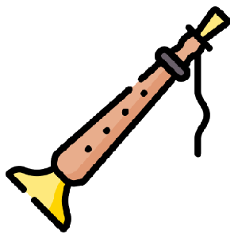
https://www.magnific.com/de/icon/shehnai_15371634

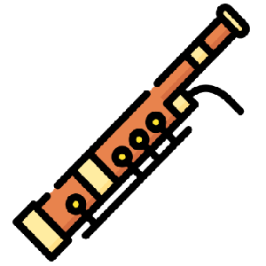

https://www.magnific.com/de/icon/fagott_1913278#fromView=search&page=1&position=18&uuid=e1e8272b-6557-4010-be96-e0f84d6503b8


https://www.magnific.com/de/icon/trompete_2318260#fromView=search&page=1&position=13&uuid=0e4dfb07-d4c0-47f9-9e0b-a3fd959b6a01


https://www.magnific.com/de/icon/tuba_1118006#fromView=search&page=1&position=26&uuid=e7658a4f-f27e-493a-87b8-d691c60f119a


https://www.magnific.com/de/icon/trommel_5201576#fromView=search&page=1&position=33&uuid=e7426326-0e32-47d4-bf3a-021ea4006141


https://www.magnific.com/de/icon/dreieck_199414#fromView=search&page=1&position=18&uuid=49890dfd-f028-4d09-a1b8-ddf9c8cd126f


https://www.magnific.com/de/icon/xylophon_8939192#fromView=search&page=1&position=26&uuid=c407dbb9-5508-4c55-b0fa-c8a8e97081ae


https://www.magnific.com/de/icon/harfe_9810449#fromView=search&page=1&position=16&uuid=bba449ed-6ec0-459e-9f5e-4a1cee3b4ea2

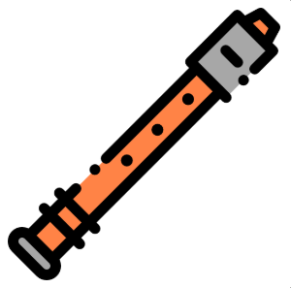
https://www.magnific.com/de/icon/floete_934105#fromView=search&page=1&position=85&uuid=a31e8da0-181f-4175-ba36-a70dfe72d828



https://www.magnific.com/de/icon/tuba_2591476#fromView=search&page=1&position=72&uuid=13f856b4-4a8c-4e71-a9cd-56807a814508


https://www.magnific.com/de/icon/instrument_15484757#fromView=search&page=1&position=3&uuid=3c95bc42-9eeb-4906-9ebf-09827c224fce

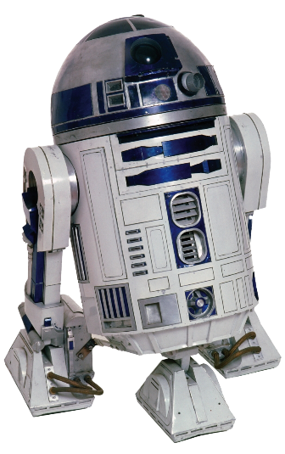
https://www.pngmart.com/image/170255

